SPAT PROFILE

Colophon
Published by | Talking Traffic
Content | subWG NL profile
Editorial | MAPtm
Date | 16-11-2017
Status | Final
Version number | 2.0

Contents
1 Introduction—3
1.1 Purpose of this Document—3
1.2 SPAT Message—3
1.3 Assumptions—3
1.4 Legend—3
1.5 Document history—4
2 Signal Phase and Timing (SPAT) Profile—5
Annex A: Summary of SPAT profile—18
Annex B: Bit string example—20
Annex C: State Diagram—21
Annex D: Members subWG NL profile—22

- Introduction
  - Purpose of this Document
This document provides the Dutch Profile for the SPAT message. It offers an interpretation of data elements and describes the use of them as extension to the standards.
  - SPAT Message
The Signal Phase and Timing (SPAT) message is used to convey the current status of one or more signalized intersections. Along with the MapData message (which describes a full geometric layout of an intersection) the receiver of this message can determine the state of the signal phasing and when the next expected phase will occur.

The SPAT message sends the current movement state of each active phase in the system as needed (such as values of what states are active and values at what time a state has begun/does begin earliest, is expected to begin most likely and will end latest). The state of inactive movements is not normally transmitted. Movements are mapped to specific approaches and connections of ingress to egress lanes and by use of the SignalGroupID in the MapData message.

The current signal pre-emption and priority status values (when present or active) are also sent. A more complete summary of any pending priority or pre-emption events can be found in the Signal Status message.
  - Assumptions
The following standards have been used to prepare this profile.

- SAE J2735, Dedicated Short Range Communications (DSRC) Message Set Dictionary, March 2016
- ISO TS19091, Intelligent transport systems — Cooperative ITS — Using V2I and I2V communications for applications related to signalized intersections, 2016(E)
- ETSI 103 301, Intelligent Transport Systems (ITS); Vehicular Communications; Basic Set of Applications; Facilities layer protocols and communication requirements for infrastructure services, V1.1.1 (2016-11)
- ETSI TS102 894-2, Intelligent Transport Systems (ITS); Users and applications requirements; Part 2: Applications and facilities layer common data dictionary, V1.2.1 (2014-09)
  - Legend
Chapter 2 contains the actual profile describing how the data frames (DFs) and data elements (DEs) shall be used for the implementation of the SPAT message.

The description of the DFs and DEs can be found in aforementioned standards. The description of the DEs and DFs in this document build upon the descriptions in these standards.

The font style of the name of DEs and DFs indicates the status as defined in the standards:

- Bold: required by the standard;
- Italic: these are optional in the standard;
- Underlined: one of these can be chosen (OR);

The status in the profile is indicated in a separate column by means of one of the following labels:

- Mandatory. This DF or DE is mandatory in the standard and is thus always provided.
- Profiled. This DF or DE is mandatory in the profile although optional in the standard. It is therefore assumed that this DF or DE will always be provided.
- Conditional. This DF or DE is mandatory in specific conditions and not used in other conditions. The conditions are provided in the profile.
- Optional. This DF or DE is optional in the standard as well as in the profile.
- Used. This DF or DE is a choice in the standard and used in the profile. It is therefore assumed that this DF or DE can be provided.
- Not used. This DF or DE is optional or a choice in the standard but not used in the profile. The response to the use of this DF or DE is therefore not guaranteed.
- Future use. This DF or DE is not relevant for use cases currently in scope and therefore not profiled in the current version of the profile.
- Bold. Applies to attributes in an enumeration or bitstring and indicates the attribute shall be assigned if applicable. All non-bold attributes are optional.
  - Document history

Version | Date | Changes
0.1 | 22-03-2017 | Document and table structure (Martijn Harmenzon)
0.2 | 27-03-2017 | Contribution from Eric Koenders
0.3 | 04-04-2017 | Review and contributions from Jaap Vreeswijk. First draft
0.5 | 11-04-2017 | Version including new comments from subWG
0.6 | 01-05-2017 | Version including comments WG meeting 21st of April
0.7 | 12-05-2017 | Version with new comments, input WG meeting 12th of May
1.0 | 18-05-2017 | Final version for broader review
1.1 | 15-06-2017 | Minor revisions which are tracked in Annex C + summary of SPAT profile added in Annex A.
1.2 | 29-06-2017 | Final revised version for approval
1.8 | 02-11-2017 | Revised version for approval
2.0 | 16-11-2017 | Version approved by WG Techniek on 16th of November ‘17

- Signal Phase and Timing (SPAT) Profile
Standard |  |  |  | Profile
Level |  | Field | Meaning | Status | Content | Value
Header container (ItsPduHeader - ETSI TS 102 894-2 V1.2.1)
 | protocol-Version |  | Version of the protocol. | Fixed | Current version is 1. | Set to 1
 | messageID |  | Indicates the type of message. | Fixed | Examples are denm(1), cam(2), spat(4) etc. | Set to 4.
 | stationID |  | This is the ID of the station broadcasting the message. | Mandatory | A number consisting of the assembly of the RoadRegulatorID and the IntersectionID | Set by application.

Standard |  |  |  |  |  |  | Profile
Level |  | Field | Meaning |  |  | Status |  |  | Content | Value
Level 0: SPAT
0.1 | timeStamp  [MinuteOfTheYear] |  | The MinuteOfTheYear data element expresses the number of elapsed minutes of the current year in the time system being used (typically UTC time). |  |  | Not used |  |  | The time stamps used for the ETSI header and the IntersectionStateList data frame make this data element redundant. | -
0.2 | name  [DescriptiveName] |  | The DescriptiveName data element is used to provide a human readable and recognizable name for the feature that follows. |  |  | Not used |  |  | The DescriptiveName used for the Intersection-StateList data frame makes this data element redundant. | -
0.3 | intersections  [Intersection-StateList]  (1..32) |  | The IntersectionStateList data frame consists of a list data IntersectionState entries. | IntersectionState  The IntersectionState data frame is used to convey all the SPAT information for a single intersection. |  | Mandatory |  |  | One IntersectionState for each independent conflict area. | See level 1
0.4 | regional  [REGION.Reg-SPAT] |  | The element is used for additional "regional information”, as defined in ISO/PDTS 19091. |  |  | Not used |  |  | - | -
Level 1: IntersectionStateList → IntersectionState
1.1 | name  [DescriptiveName] |  | The DescriptiveName data element is used to provide a human readable and recognizable name for the feature that follows. |  |  | Profiled |  |  | Mandatory in Dutch profile as opposed to standard. Human readable and recognizable for road authority. Maximum 63 characters. Shorter is better. | Set by application
1.2 | id  [Intersection-ReferenceID] |  | The IntersectionReference-ID is a globally unique value set, consisting of an optional RoadRegulatorID and a required IntersectionID assignment, providing an unique mapping to the intersection MAP. | region  [RoadRegulatorID]  The RoadRegulatorID data element is a globally unique identifier assigned to a regional authority. |  | Profiled |  |  | Mandatory in Dutch profile as opposed to standard. For each road operator a RoadRegulatorID is provided in the document ‘Addendum VRA en geregeld Kruisingsvlak Identificatie 20170728’. | Set by application
 |  |  |  | id  [IntersectionID ]  The IntersectionID is used within a region to uniquely define an intersection within that country or region. |  | Mandatory |  |  | The identifier shall be defined by the road operator. | Set by application
1.3 | Revision  [MsgCount ] |  | The MsgCount data element is used to provide a sequence number within a stream of messages with the same DSRCmsgID and from the same sender. Depending on the application the sequence number may change with every message or may remain fixed during a stream of messages when the content within each message has not changed from the prior message sent. |  |  | Mandatory |  |  | The revision number must be increased by 1 each time the MapData of this intersection changes. The revision numbers of SPAT and MAP much be the same as an indication that the right MAP version is used. | Set by application
1.4 | status  [Intersection-StatusObject ] |  | The IntersectionStatusObject data element contains Advanced Traffic Controller (ATC) status information. |  |  | Mandatory |  |  | Types:  - manualControlIsEnabled (0),  - stopTimeIsActivated (1),  - failureFlash (2),  - preemptIsActive (3),  - signalPriorityIsActive (4),  - fixedTimeOperation (5),  - trafficDependentOperation (6),  - standbyOperation (7),  - failureMode (8),  - off (9),  - recentMAPmessageUpdate (10),  - recentChangeInMAPassignedLanesIDsUsed (11),  - noValidMAPisAvailableAtThisTime (12),  - noValidSPATisAvailableAtThisTime (13)  Bits 14,15 reserved at this time and shall be zero | Set by application
1.5 | moy  [MinuteOfTheYear ] |  | The MinuteOfTheYear data element expresses the number of elapsed minutes of the current year in the time system being used (typically UTC time). |  |  | Profiled |  |  | Mandatory in profile as opposed to standard. | Set by application
1.6 | timeStamp  [Dsecond ] |  | The DSRC second expressed in this data element represents the milliseconds within the current UTC minute. |  |  | Profiled |  |  | Mandatory in profile as opposed to standard. | -
1.7 | enabledLanes  [EnabledLaneList] |  | The Enabled Lane List data frame is a sequence of lane IDs for lane objects that are activated in the current map configuration. These lanes, unlike most lanes, have their RevocableLane bit set to one (asserted). Such lanes are not considered to be part of the current map unless they are in the Enabled Lane List. | LaneID  The LaneID data element conveys an assigned index that is unique within an intersection. It is used to refer to that lane by other objects in the intersection map data structure. Lanes may be ingress (inbound traffic) or egress (outbound traffic) in nature, as well as barriers and other types of specialty lanes. |  | Conditional |  |  | Mandatory in profile for specific situations with dynamic lane configurations, e.g. a lane that is used for different manoeuvres at different times of the day. Otherwise not used.  The valid configuration can be derived from the active variant as indicated by the intersection controller (e.g. VlogIndicator). | Set by application
1.8 | states  [MovementList]  (1..255) |  | The MovementList data frame consists of a list of MovementState entries.  Each Movement is given in turn and contains its signal phase state, mapping to the lanes it applies to, and point in time it will end, and it may contain both active and future states | MovementState  The MovementState data frame is used to convey various information about the current or future movement state of a designated collection of one or more lanes of a common type.  It is used in the SPAT message to convey every active movement in a given intersection so that vehicles, when combined with certain map information, can determine the state of the signal phases. |  | Conditional |  |  | Mandatory in case the status (see 1.4) indicates normal operation, i.e. IntersectionStatusObject bit 3 to 6. Otherwise states are not used. | See level 2
1.9 | maneuverAssistList  [Maneuver-AssistList]  (1..6) |  | The ManeuverAssistList data frame consists of a list of ConnectionManeuver-Assist entries. | ConnectionManeuverAssist  The ConnectionManeuver-Assist data frame contains information about the the dynamic flow of traffic for the lane(s) and maneuvers in question (as determined by the LaneConnectionID).  Note that this information can be sent regarding any lane-to-lane movement; it need not be limited to the lanes with active (non-red) phases when sent. |  | Not used |  |  | At this level the values apply to all movements of the intersection. In the Dutch profile this data frame is only used in level 2, where values are assigned to individual movements. | See level 6
1.10 | regional  [REGION.Reg-IntersectionState] |  | The element is used for additional "regional information”, as defined in ISO/PDTS 19091. |  |  | Not used |  |  | Extension allow to transmit activePrioritizations which consists of a sequence of stationID, priorState and signalGroup. Offers an alternative to the SSM message. | -
Level 2: MovementList MovementState
2.1 | movementName  [DescriptiveName ] |  | The DescriptiveName data element is used to provide a human readable and recognizable name for the MovementState data frame. |  |  | Profiled |  |  | Mandatory in profile as opposed to standard. The DescriptiveName data element is set to human readable and recognizable SignalGroupID. For example, fc02, fc21, SG31, SG41, etc. | Set by application
2.2 | signalGroup  [SignalGroupID ] |  | The SignalGroupID data element is an index used to map between the internal state of one or more signal controllers and a common numbering system that can represent all possible combinations of active states (movements and phases). All possible movement variations are assigned a unique value within the intersection. |  |  | Mandatory |  |  | The SignalGroupID data element is used to map to lists of lanes (and their descriptions) to which this MovementState data applies to. | Set by the application
2.3 | state-time-speed  [Movement-EventList]  (1..16) |  | The MovementEventList data frame consists of a list of MovementEvent entries. | MovementEvent  The MovementEvent data frame contains details about a single movement. It is used by the movement state to convey one of number of movements (typically occurring over a sequence of times) for a SignalGroupID. |  | Mandatory |  |  | The size of the MovementEventList is subject to the TimeIntervalConfidence. If the time intervals cannot be provided with sufficient confidence*, no additional MovementEvent will be provided.  * This threshold will be defined quantitatively in a later stage based on practical experience. | See level 3
2.4 | maneuverAssistList  [Maneuver-AssistList]  (1..6) |  | The ManeuverAssistList data frame consists of a list of ConnectionManeuverAssist entries.  -- This information may also be placed in the IntersectionState when common information applies to different lanes in the same way | ConnectionManeuverAssist  The ConnectionManeuver-Assist data frame contains information about the the dynamic flow of traffic for the lane(s) and maneuvers in question (as determined by the LaneConnectionID).  Note that this information can be sent regarding any lane-to-lane movement; it need not be limited to the lanes with active (non-red) phases when sent. |  | Profiled |  |  | Mandatory in profile as opposed to standard unless the data is not available. Used to convey the queue length. | See level 6
2.5 | regional  [REGION.Reg-MovementState] |  | The element is used for additional "regional information”, as defined in ISO/PDTS 19091. |  |  | Not used |  |  | - | -
Level 3: MovementEventList MovementEvent
3.1 | eventState  [Movement-PhaseState ] |  | The MovementPhaseState data element provides the overall current state of the movement (in many cases a signal state), including its core phase state and an indication of whether this state is permissive or protected.  It is expected that the allowed transitions from one state to another will be defined by regional deployments. Not all  regions will use all states; however, no new states are to be defined.  Permissive is referred to as a "round ball" while protected implies it has a directional arrow associated with it.  A diagram of the above states is included in Annex D. |  |  | Mandatory |  |  | The MovementPhaseState data element can be set to:  Unlit (dark):  - unavailable  e.g. power outage  - dark  e.g. outside of operating hours  Reds:  - stop-Then-Proceed  - stop-And-Remain  Greens:  - Pre-Movement  - permissive-Movement-Allowed  - protected-Movement-Allowed  Yellows / Ambers:  - permissive-clearance  - protected-clearance  - caution-Conflicting-Traffic  e.g. outside of operating hours | Set by application
3.2 | timing  [TimeChange-Details] |  | The TimeChangeDetails data frame conveys details about the timing of a phase within a movement. The core data concept expressed is the time stamp (time mark) at which the related phase will change to the next state. This is often found in the MinEndTime element, but the other elements may be needed to convey the full concept when adaptive timing is employed.  The data Element “DE_TimeMark” is defined as an offset to the UTC full hour with a resolution of 36 000 in units of 1/10th of second. For proper calculation, be aware of time periods beyond the full hour (“TimeMark” value > 36 000) to avoid negative values.  For a calculation of the duration of a traffic light signal phase change, the limited range of the “TimeMark” has to be considered. See the example in TS19091, section G.9.2.3. |  |  | Profiled |  |  | Mandatory in profile as opposed to standard (to stress TimeChangeDetails are the main purpose of the SPAT message), unless MovementPhaseState equals 0, 1 or 9, or when the data is not available (e.g. for specific movements). | See level 4
3.3 | speeds  [AdvisorySpeedList]  (1..16) |  | The AdvisorySpeedList data frame consists of a list of AdvisorySpeed entries. | AdvisorySpeed  The AdvisorySpeed data frame is used to convey a recommended traveling approach speed to an intersection from the message issuer for different distances to the stop line and various traveller and vehicle types. |  | Profiled |  |  | Mandatory in profile as opposed to standard in case of physical roadside signage displaying dynamic advisory speeds. Recommended to be used in other cases.  AdvisorySpeed is a general recommendation for the particular SignalGroupID and not tied to one specific MovementPhaseState. Therefore, it is provided only one time, with the first MovementEvent. | See level 5
3.4 | regional  [REGION.Reg-MovementEvent] |  | The element is used for additional "regional information”, as defined in ISO/PDTS 19091. |  |  | Conditional |  |  | One extension was defined for this data frame:  exceptionalCondition [ExceptionalCondition]  Mandatory in case of exceptional waiting or sudden increases in waiting time, types:  - unknown  - publicTransportPriority  - emergencyVehiclePriority  - trainPriority  - bridgeOpen  - vehicleHeight  - weather  - trafficJam  - tunnelClosure  - meteringActive  - truckPriority  - bicyclePlatoonPriority  - …  The signal (ITS) application sets this DE and deactivates it. | Set by application
Level 4: MovementEvent TimeChangeDetails
4.1 | startTime  [TimeMark] |  | The StartTime element is used to relate when the phase itself started or is expected to start. This in turn allows the indication that a set of time change details refers to a future phase, rather than a currently active phase.  By this method, timing information about "pre" phase events (which are the short transitional phase used to alert OBEs to an impending green/go or yellow/caution phase) and the longer yellow-caution phase data is supported in the same form as various green/go phases.  In theory, the time change details could be sent for a large sequence of phases if the signal timing was not adaptive and the operator wished to do so. In practice, it is expected only the "next" future phase will commonly be sent. |  | Not used |  |  | - |  | -
4.2 | minEndTime  [TimeMark] |  | The element MinEndTime is used to convey the earliest time possible at which the phase could change, except when unpredictable events relating to a pre-emption or priority call disrupt a currently active timing plan. |  | Mandatory |  |  | Typically, pre-configured as the minimum green/red time. Unknown = 36001. |  | Set by application
4.3 | maxEndTime  [TimeMark] |  | The element MaxEndTime is used to convey the latest time possible which the phase could change, except when unpredictable events relating to a pre-emption or priority call come into play and disrupt a currently active timing plan. |  | Optional |  |  | Typically, pre-configured as the maximum green/red time. Unknown = 36001. |  | Set by application
4.4 | likelyTime  [TimeMark] |  | The element likelyTime is used to convey the most likely time the phase changes. This occurs between MinEndTime and MaxEndTime and is only relevant for traffic-actuated control programs. |  | Profiled |  |  | Mandatory in profile as opposed to standard (to stress the importance of this TimeMark), unless data is not available (e.g. specific movements). Indicates the expected / predicted end time of the phase. Unknown is 36001. |  | Set by application
4.5 | confidence  [TimeInterval-Confidence ] |  | The element confidence is used to convey basic confidence data about the likelyTime. |  | Profiled |  |  | Mandatory in profiles as opposed to standard when likelyTime is provided. In addition, an alternative meaning for the values is defined compared to the standard.  The definition and method is as follows: • First construct the standard deviation of the likelyTime as a percentage of the likelyTime: standard deviation likelyTime divided by the likelyTime. For example, 2 seconds divided by 10 seconds = 20%.  • Next, define the probability of the likelyTime: 100% - standard deviation of the likelyTime as percentage of the likelyTime. For example, 100% - 20% = 80%.  • Round to the nearest value in the table given by SAE J2735 (see below). For example, 81% is closest to the calculated 80%, which provides the value 8.  • Reversely, a value of 10 provides a probability value of 88%. This means that the standard deviation of the likelyTime is 12%. In other words, the standard deviation of a likelyTime of 30 seconds is 3,6 seconds.  • Assuming normal distribution the following applies:  o The likelyTime is within 26,4 and 33,6 seconds with 68,27% probability.  o The likelyTime is within 22,8 and 37,2 seconds with 95,44% probability.  o The likelyTime is within 19,2 and 40,8 seconds with 99,73% probability. |  | Set by application
4.6 | nextTime  [TimeMark] |  | The element nextTime is used to express a general (and presumably less precise) value regarding when this phase will next occur. This is intended to be used to alert the OBE when the next green/go may occur so that various ECO driving applications can better manage the vehicle during the intervening stopped time. |  | Optional |  |  | The data element nextTime typically equals likelyTime + the cycle time. Since most signal controllers in the Netherlands use inputs, such as detectors, to dynamically adjust signal timing and phasing, the ‘cycle time’ is not constant and most likely not available. Therefore, this data element is optional. Unknown = 36001.  This data element is mandatory in case the control programs have a constant cycle time. For example, fixed time or semi-fixed time (“half star”) control programs. |  | Set by application
Level 5: MovementEvent AdvisorySpeed
5.1 | type  [Advisory-SpeedType] |  | The AdvisorySpeedType data element relates the type of travel to which a given speed refers. This element is typically used as part of an AdvisorySpeed data frame for signal phase and timing data. |  | Mandatory |  |  | As the main purpose is (dynamic) green wave the value shall be set to 1. |  | 1
5.2 | speed  [SpeedAdvice] |  | This data element represents the recommended velocity of an object, typically a vehicle speed along a roadway,  expressed in unsigned units of 0.1 meters per second. |  | Profiled |  |  | Mandatory in profile as opposed to standard. If the AdvisorySpeed DF is used this is the primary value.  Typically the SpeedAdvice considers one intersection, however, the application may have computed the speed advice considering multiple intersections. |  | Set by application
5.3 | confidence  [SpeedConfidence] |  | The SpeedConfidence data element is used to provide the 95% confidence level for the currently reported value of DE_Speed, taking into account the current calibration and precision of the sensor(s) used to measure and/or calculate the value. |  | Not used |  |  | As the SpeedAdvice is already described as bandwidth for specific road segments, a confidence value is redundant. |  | -
5.4 | distance  [ZoneLength] |  | The ZoneLength data element is used to provide an estimated distance from the stop bar, along the lane centreline back in the lane to which it pertains. It is used in various ways to relate this distance value. When used with clearance zones, it represents the point at which the driver can successfully execute the connection maneuver. It is used in the Clearance Maneuver Assist data frame to relate dynamic data about the lane. It is also used to relate the distance from the stop bar to the rear edge of any queue. It is further used within the context of a vehicle's traveling speed to advise on preferred dynamic approach speeds.  -- Unit = 1 meter,  -- The distance indicates the region for which the advised speed is recommended, it is specified upstream from the stop bar along the connected egressing lane |  | Profiled |  |  | Mandatory in profile as opposed to standards.  The distance indicates the region for which the advised speed is recommended, it is specified upstream from the stop bar in units of 1 meter. The first zone starts at the stop line and ends at the indicated distance. |  | Set by application
5.5 | class  [RestrictionClassID] |  | The RestrictionClass data element defines an intersection-unique value to convey data about classes of users.  The typical use of this element is to map additional movement restrictions or rights (in both the MAP and SPAT messages) to special classes of users (trucks, high sided vehicles, special vehicles etc.). |  | Not used |  |  | Absent implies that the AdvisorySpeed applies to all users of the Movement, or in case of a shared lane to all motor vehicle types. |  | -
5.6 | regional  [REGION.Reg-AdvisorySpeed] |  | The element is used for additional "regional information”, as defined in ISO/PDTS 19091. |  | Not used |  |  | - |  | -
Level 6: ManeuverAssistList ConnectionManeuverAssist
6.1 | connectionID  [Lane-ConnectionID] |  | The LaneConnectionID data entry is used to state a connection index for a lane to lane connection (defined in MAP). It is used to relate this connection and any dynamic clearance data sent in the SPAT. |  | Mandatory |  |  | Unique index value. |  | Set by application
6.2 | queueLength  [ZoneLength] |  | The queueLength data entry is used to state the distance from the stop line to the back edge of the last vehicle in the queue as measured along the lane centre line. |  | Optional |  |  | Highly recommended as queue information can improve the quality of service considerably. To be considered mandatory if available.  Unit = 1 meter, 0 = no queue. Used to improve the in-vehicle calculation of the SpeedAdvice. |  | Set by application
6.3 | available-StorageLength  [ZoneLength] |  | Distance (e.g. beginning from the downstream stop-line up to a given distance) with a high probability for successfully executing the connecting manoeuvre between the two lanes during the current cycle. Used for enhancing the awareness of vehicles to anticipate if they can pass the stop line of the lane. Used for optimizing the green wave, due to knowledge of vehicles waiting in front of a red light (downstream). |  | Not used |  |  | Out of scope of current use cases. |  | -
6.4 | waitOnStop  [WaitOnStopline] |  | The WaitOnStopline data element is used to indicate to the vehicle that it must stop at the stop line and not move past. |  | Not used |  |  | Out of scope of current use cases. |  | -
6.5 | pedBicycleDetect  [Pedestrian-BicycleDetect] |  | The PedestrianBicycleDetect data element is used to provide an indication of whether Pedestrians and/or Bicyclists have been detected in the crossing lane. |  | Not used |  |  | Out of scope of current use cases. |  | -
6.6 | regional  [REGION.Reg-ConnectionManeuverAssist] |  | The element is used for additional "regional information”, as defined in ISO/PDTS 19091. |  | Not used |  |  | Extensions allow to transmit vehicleToLanePositions and rsuGNSSOffset. |  | -

Annex A: Summary of SPAT profile
bold = mandatory/used
bold-italic = conditional
italic = optional
strikethrough = not used
red = desired extensions

timestamp [MinuteOfTheYear]
name [DescriptiveName]
intersections [Intersection-StateList]
IntersectionState
name [DescriptiveName]
id [Intersection-ReferenceID]
region [RoadRegulatorID]
id [IntersectionID]
Revision [MsgCount]
Status [IntersectionStatusObject]
moy [MinuteOfTheYear]
timestamp [Dsecond]
enabledLanes [EnabledLaneList]
LaneID
states [MovementList]
MovementState
movementName [DescriptiveName]
signalGroup [SignalGroupID]
state-time-speed [MovementEventList]
MovementEvent
eventState [MovementPhaseState]
timing [TimeChangeDetails]
startTime [TimeMark]
minEndTime [TimeMark]
maxEndTime [TimeMark]
likelyTime [TimeMark]
confidence [TimeIntervalConfidence]
nextTime [TimeMark]
speeds [AdvisorySpeedList]
AdvisorySpeed
type [AdvisorySpeedType]
speed [SpeedAdvice]
confidence [SpeedConfidence]
distance [ZoneLength]
class [Restriction-ClassID]
regional [REGION.Reg-AdvisorySpeed]
regional [REGION.Reg-MovementEvent]
addGrpC [MovementEvent-addGrpC]
exceptionalCondition [ExceptionalCondition]
maneuverAssistList [ManeuverAssistList]
ConnectionManeuverAssist
connectionID [LaneConnectionID]
queueLength [ZoneLength]
availableStorageLength [ZoneLength]
waitOnStop [WaitOnStopline]
pedBicycleDetect [PedestrianBicycleDetect]
regional [REGION.Reg-ConnectionManeuverAssist]
regional [REGION.Reg-MovementState]
maneuverAssistList [ManeuverAssistList]
ConnectionManeuverAssist
connectionID [LaneConnectionID]
queueLength [ZoneLength]
availableStorageLength [ZoneLength]
waitOnStop [WaitOnStopline]
pedBicycleDetect [PedestrianBicycleDetect]
regional [REGION.Reg-ConnectionManeuverAssist]
regional [REGION.Reg-IntersectionState]
regional [REGION.Reg-SPAT]

Annex B: Bit string example
A bit string is an arbitrarily long array of bits. Specific bits can be identified by parenthesized integers and assigned names. As an example, the bit string for the data element LaneSharing is shown in Figure 1.

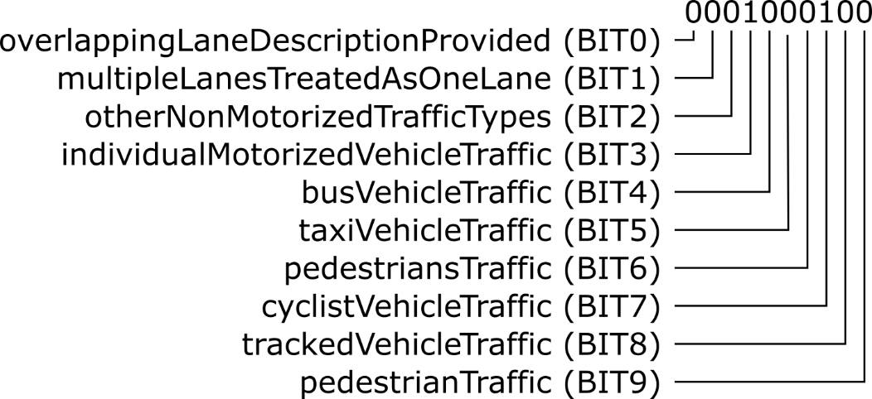

Figure 1 Bit string example

The example shows the 10 bit sting ‘0001000100’, where BIT3and BIT7 are set from left to right. This indicates that user types individualMotorizedVehicleTraffic and cyclistVehicleTraffic can access and use the respective lane.

Annex C: State Diagram
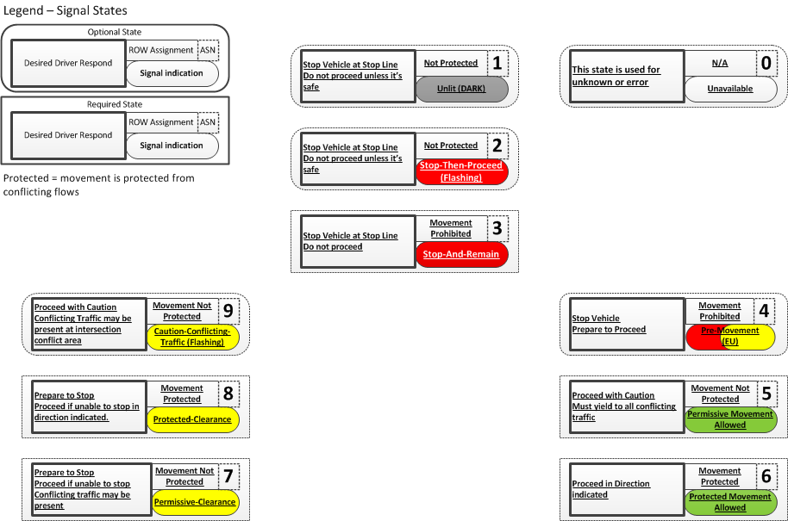
Figure 2 - State Diagram

Annex D: Members subWG NL profile
Jaap Vreeswijk - MAPtm
Martijn Harmenzon – MAPtm
Martin Barto – Vialis
Eric Koenders – Dynniq
Peter Luns – Siemens
Eddy Verhoeven – Siemens
Peter Smit – Swarco
Jaap Zee – Swarco
Kartik Mundaragi Shivakumar – DHDHV
Klaas-Jan op den Kelder – RHDHV
Wannes de Smet – BeMobile
Arie Schreuders – Sweco
Bram Schiltmans – RWS

